**ASSIGNMENT SOLUTIONS –**

**1. What is the use of the git add command?**

The git add command stages changes (like modified or new files) so they can be committed. It tells Git which files to include in the next commit.

**2. Write the command to create a branch “feature-group”.**

git branch feature-group

This creates a new branch named feature-group from the current branch.

**3. What is a pull request? Write the steps involved in creating a pull request.**

A pull request (PR) is a way to propose and review code changes before merging into the main branch.  
**Steps:**

1. Push your changes to a branch.
2. Go to the GitHub repository.
3. Click "Compare & pull request".
4. Add a title/description and click "Create pull request".

**4. How do you add collaborators?**

Go to your GitHub repository, click **Settings > Collaborators > Add people**.  
Enter their GitHub username or email and click **Add**.

**5. What is the command used to commit our changes in GitHub repo?**

git commit -m "Your commit message"

This command saves the staged changes with a message describing what you did.

**6. Create a GitHub account and repository to save all your assignment tasks. Example repository name: rg-assignments.**

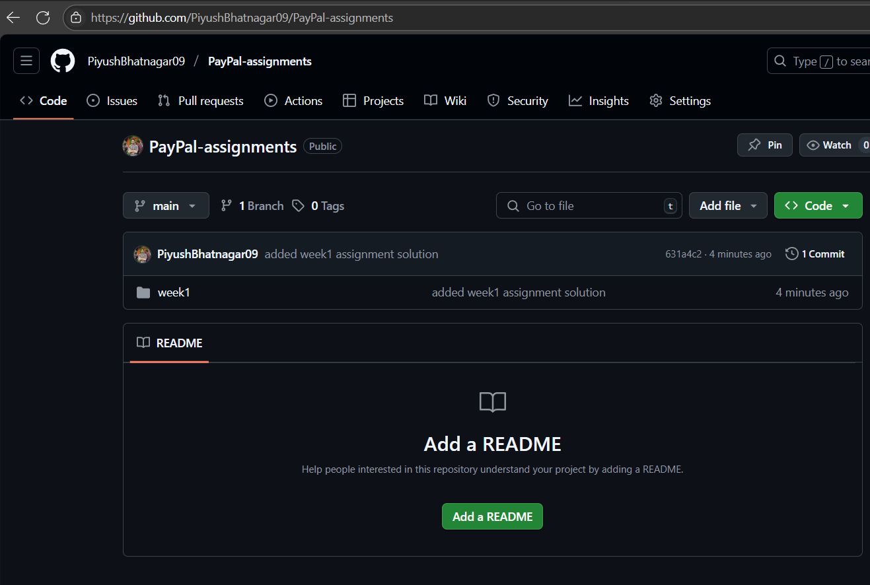

**7. Create a branch called feature-java (you can use it later to push all your java related tasks to this branch).**

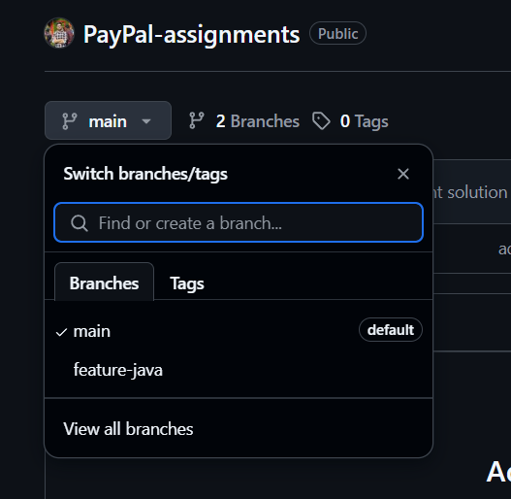

git checkout -b feature-java

This creates and switches to the new branch feature-java.

**8. Install IntelliJ IDE. Create a simple Java project displaying “Hello World!!” and share the screenshot.**

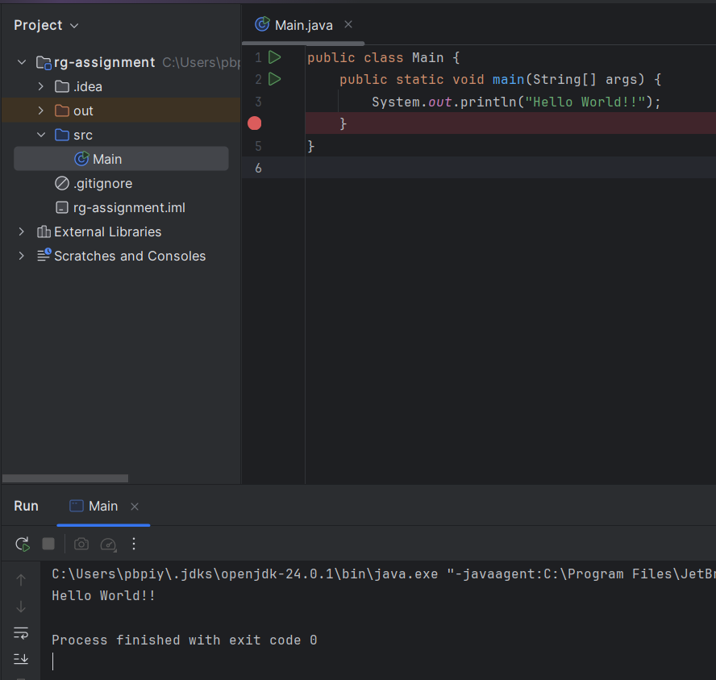

**9. In IntelliJ IDE, explore the shortcut keys for the following:**

* **To run the project** → Shift + F10
* **To select a line** → Home, then Shift + End
* **To comment/uncomment a line** → Ctrl + /
* **To delete a line** → Ctrl + Y